1. What is the minimum number of lines needed to join 26 eggs (points)?
(A) 0
(B) 1
(C) 25
(D) 26
(E) NOTA
2. Sam likes to have a square table to eat his green eggs and ham, whose diagonal is half
of the length of the diagonal of a square whose area is 16. What is the area of Sam's table?
(A) 4
(B) 8
(C) 12
(D) 16
(E) NOTA
3. Train carriage A,B,C,D are all on the same straight track (in that order). The
distance from carriage C to carriage D is half of the distance from carriage A to carriage B
and a third of the distance from B to C. If the distance from carriage A to carriage C is 10,
what is the distance between carriages C and D?
(A) 2
(B) 3
(C) 4
(D) 5
(E) NOTA
4. If the length of the sides of a rectangle are the roots of x 2 − 32x + 256. What is the
area of the rectangle?
(A)
(C) 51
(D) 32
(E) NOTA
5. Sam found the following statements in a book: "If you like green eggs and ham, then
you are a mouse. If you are a mouse, then you are small." Is the statement: "If you like
green eggs and ham, then you are small" correct from the Law of Syllogism?
(A) Yes
(B) No
6. Triangle ABC has points A (−4, 0),B(6, 0), and C lies on line y = 5. What is the
largest possible area of ABC?
(A) Infinity (B) 10 (C) 25 (D) 50 (E) NOTA

7. A mouse on the point (-3, -2) is trying to get to a piece of cheese at coordinates (3, 6). How far does it have to travel assuming that it travels the shortest distance?
(A) 6
(B) 8
(C) 10
(D) 12
(E) NOTA
8. Sam has agreed to eat green eggs and ham in a box with dimensions of 3, 5, and 7.
What is the diameter of the largest sphere that can fit into this box?
(A) 105
(B) 7
(C) 5
(D) 3
(E) NOTA

256

(B) 224

(A) 135
(B) 75
(C) 60
(D) 55
(E) NOTA
10. Sam-I-am has bought a giant plate for Sam to eat green eggs and ham on. If the
circumference of the plate is 8π, what is the area?
(A) 16π
(B) 8π
(C) 4π
(D) 2π
(E) NOTA
11. If the area of a square is j + 4j + 4, then what would be the length of one side?
(A) 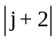
(C) j − 2
(D) 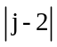
(E) NOTA
2

(B) j + 2
12. Sam-I-am decided to cut out pieces of ham from a square piece. He decided to use
the angle trisectors as guidelines. If he found out that the length of one angle trisector was
6, then what was the area of the original ham?
(A) 9
(B) 18
(C) 27
(D) 36
(E) NOTA
13. While reading a book, the fox saw a sequence that looked like this: 1, 1, 2, 3, 5, 8, 13...
Unfortunately, the rest of this infinite sequence was not written down in the book. The fox
wants to know what the 10th term is. What is the 11th term of this sequence?
(A) 21
(B) 34
(C) 55
(D) 89
(E) NOTA
14. A rhombus is made out of four 3 − 4 − 5 right triangles. What is the area of the
rhombus?
(A) 60
(B) 48
(C) 24
(D) 12
(E) NOTA
15. What is the definition of a point?
(A) A place to eat ham (B) Undefined
(C) A dot
(D) An island
(E) NOTA
16. Sam only likes to eat green eggs inside a triangular house. If the triangular house
has 3 and 4 as two of its sides, what could be the third one?

(A) 7
(B) 1
(C) 
(D)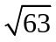

(E) NOTA

9, Lines AB and CD are parallel lines. 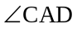is a 45 degree angle and 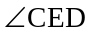 is a right
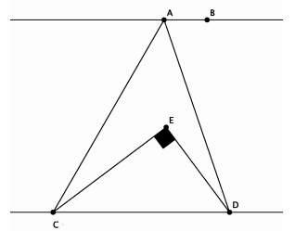angle. What is 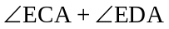?
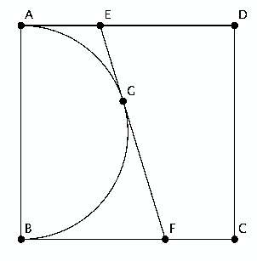
17. In the figure below, lines BC intersects ED at A. If is 70 degrees, what is
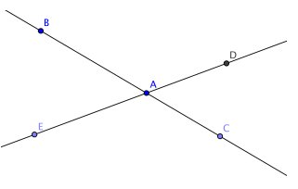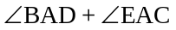?
(A) 90
(B) 140
(C) 180
(D) 220
(E) NOTA
18. What is the equation of the line containing (−3, 2) and (−1, 1)?
(A) −x − 2y = −1 (B) x + 2y = −1 (C) x − 2y = 1 (D) x − 2y = −1 (E) NOTA

19. Square ABCD has semicircle with diameter AB. If EG= 4 and GF = 9, then what
is the length of a side of ABCD?
(A) 8
(B) 10
(C) 11
(D) 12
(E) NOTA
20. Sam-I-am decided to cut out a pentagon from a rectangle to make a table. The
pentagonal table's dimensions are 16, 12, 13, 5, 8 (not necessarily is this order). What is the
area of the pentagon?
(A) 180 (B) 186 (C) 192 (D) 198 (E) NOTA

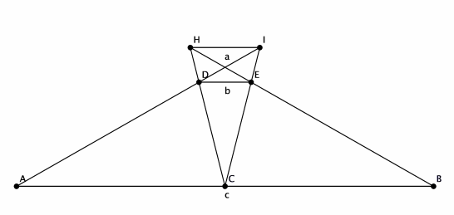
21. Which of the following can not be sides of a triangle?
(A) 3-4-5 (B) 1.01-4-5 (C) .99-4.02-5
(D) 1-1.5-2
(E) NOTA
22. Three lines lie on a plane, what is the smallest number of regions the plane can be
divided by the lines?
(A) 0
(B) 1
(C) 2
(D) 3
(E) NOTA
23. Triangles ABC and DEF are similar. If 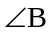 = 50 and 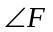 = 30, then what is
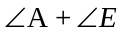?
(A) 30
(B) 50
(C) 80
(D) 150
(E) NOTA
24. Lines a,b, and c are parallel. HEB is collinear, and so is IDA. If a = 4 and b = 3,
then what is c ?
(A) 12
(B) 18
(C) 26
(D) 30
(E) NOTA
25. Triangle ABC has altitudes AD and BE. If AD = 8, BC = 5 and AC = 10, then
what is the length of BE?
(A) 2
(B) 4
(C) 5
(D) 8
(E) NOTA
26. What is the area of a regular polygon given that its semiperimeter is 5 and its
apothem is 12?
(A) 12
(B) 30
(C) 60
(D) 120
(E) NOTA
27. Circle O has tangents CB and CD with 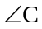 = 60 and points B and D on the circle.
If the radius of circle O is 5, what is the area of ODCB?
(A) 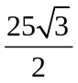

(B) 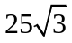
(C) 25
(D) 50
(E) NOTA
28, Sam has agreed to play a dart game. The board will be a circle inscribed within a
square of side length 232. If Sam hits the area that is in the square but outside the circle, he
won't have to eat ham. What is the probability that Sam won't have to eat ham assuming
he always hits inside the square.
(A) 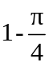

(B) 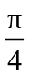

(C) 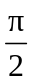
(D) 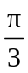

(E) NOTA
29. How many sides does a pentadecagon have?
(A) 5
(B) 15
(C) 25
(D) 105
(E) NOTA
30. What is the shape of an Olympics medal?
(A) Square (B) Blob (C) Pentagon
(D) Circle
(E) NOTA

